CAR Purchasing Web Application

Project Plan
Car Purchasing Web Application

Author: Hagar Mohamed
Creation Date: 5/5/2019

TABLE OF CONTENTS

INTRODUCTION
Purpose of Plan
GOALS AND OBJECTIVES
Business Goals and Objectives
Project Goals and Objectives
SCOPE
Scope Definition
WBS
Work breakdown Structure……………………………………………………………………………………………

Risk Assessment
Initial Project Risk Assessment
Milestones

CONSTRAINTS
Project Constraints
PROJECT MANAGEMENT APPROACH
Project Timeline
Project Roles and Responsibilities
Communications Plan
ATTACHMENTS/APPENDICES
APPROVALS
Sign-off Sheet

INTRODUCTION

Purpose of Plan

- Car Purchasing Web Application is an innovative internet reservation software designed for cars. It’s platform that offers an easy and fast way to smoothly manage car reservation systems. The Websites provides a unified control panel with a highly-customizable booking system that enables potential clients to make online reservations within minutes.

It’s a user-friendly system that can be structured to fit the needs of independent vans and car rental agencies.

Some of its main features include:

1-the user can register and login and land on the car listing page with number of currently available cars.

2-the user can search for cars based on different search criteria.

3-the user has to the option to reserve a car from the available cars.

GOALS AND OBJECTIVES

Business Goals

The business goals and objectives for this project will focus on implementing Car Reservation System that:

- Facilitates users and buyer to search for their desired cars.

- Is easy to use.

Business Objectives

- Car Purchasing Application is a powerful system with an impressive set of features. It’s a fully integrated software designed to simplify fleet management and enable car reserve to accept online reservations with ease.

Project Goals

Sample project goals and objectives:

- Ensure that end users (“Eng. Marwan”) in all project phases.

- Accomplish project business goals and objectives within defined budget and time parameters.

- Minimize impact to standard business operations within the affected units.
.

SCOPE

Scope Definition

The Scope of this project is to make a web based system for car Purchasing application including the following:

- User able to Login and Register in websites
- Searching for car using different criteria based on color, price and model
- Online car reservation.
- Response time to not exceed 10 seconds for 90 Percentile.
- While applying a load equivalent to 500 Transaction per second on the System APIs.

Out of scope Definition

- Security testing.
- Reliability testing.
- Usability testing.
- API testing.

Work breakdown Structure

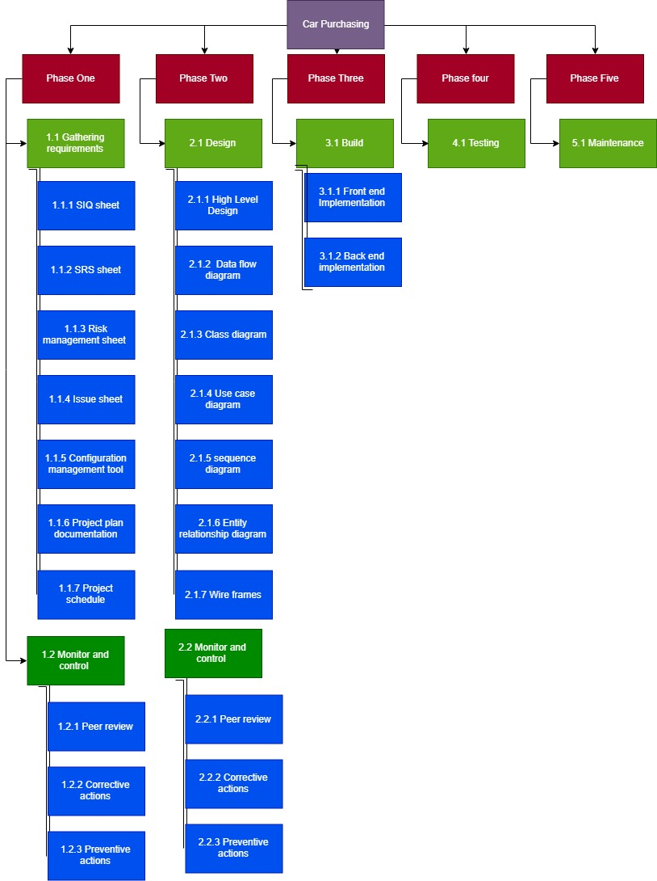

Risk Assessment

The initial Risk Assessment (following page) attempts to identify, characterize, prioritize and document a mitigation approach relative to those risks which can be identified prior to the start of the project is discussed at the Risk sheet.

The Risk Assessment will be continuously monitored and updated throughout the life of the project, with daily assessments included in the status report (see Communications Plan is discussed at the end of document) and open to amendment by the Project Manager.

Initial Project Risk Assessment

Risk | Risk Level  L/M/H | Likelihood of Event | Mitigation Strategy
Project Size
Person Hours | M: Over 200 hour | Certainty | Assigned Project Manager, engaged consultant, comprehensive project management approach and communications plan
Estimated Project Schedule | M:Well defined | Certainty | Created comprehensive project timeline with frequent baseline reviews
Team Size at Peak | H: Over 6 members | Certainty | Comprehensive communications plan, frequent meetings, tight project management oversight
Project Definition
Narrow Knowledge Level of Users | M: Knowledgeable of user area only | Likely | Assigned Project Manager(s) to assess global implications
Consultant Project Deliverables unclear | L: Well defined | Unlikely | Included in project plan, subject to amendment
Number of Team Members Unknowledgeable of Business | L: Team well versed in business operations impacted by technology | Unlikely | Project Manager and consultant to identify knowledge gaps
Project Staffing
Project Team Availability | M: Distributed team makes availability questionable | Somewhat likely | Continuous review of project momentum by all levels. Consultant to identify any impacts caused by unavailability.
Project Team’s Shared Work Experience creates poor working relationship | M: Some have worked together before | Somewhat likely | Comprehensive Communications Plan
Poor Functional Match of Package to Initial System Requirements | L: Minimal customization required | Unlikely | Although a package has not yet been selected, the Consultant has compared the initial requirements with available functionality and determined that a functional match to the initial requirements is very likely. Vendor selection will be based, in part, on how well the proposed application matches defined functional specifications.

Milestones

The following represent key project milestones, with estimated completion dates:
We had four major Milestones in this project

Milestone Estimated Completion Date
Phase I:
Completion of Requirements Gathering 4/5/2019
Phase II:
Completion of Design 11/5/2019
Phase III:
Completion of Building 18/5/2019

CONSTRAINTS

Project Constraints

The following represent known project constraints:
- Project Web based System / PC based.
- Unique Users IDs.
- Admin Features needed such as (add-delete and view )users

PROJECT MANAGEMENT APPROACH

Project Approach

Projects are complex and today, more than ever, are met with uncertainties and unpredictability. The agile methodology process seeks to respond to these uncertainties through incremental, iterative work cadences and empirical feedback. So we use Scrum agile methodology.
We use SDLC is v-Model.

Validation and verification strategies:

See the external V & V strategies documentation in Cm Tool.

Project Timeline

Timeline of project 25/5/2019

Roles & Responsibility

See the external RACH sheet in CM tool
Communications Plan
Disseminating knowledge about the project is essential to the project’s success. Project participants desire knowledge of what the status of the project is and how they are affected. Furthermore, they are anxious to participate. The more that people are educated about the progress of the project and how it will help them in the future, the more they are likely to participate and benefit.

This plan provides a framework for informing, involving, and obtaining buy-in from all participants throughout the duration of the project.

Audience This communication plan is for the following audiences:

- Project Manager
- Scrum Team Participants
- Subject Matter Experts.

Communications Outreach The following is a list of communication events that are established for this project:

Daily Stand-up Meeting:

A daily scrum meeting is held in the morning, as it helps set the context for the coming day's work. These scrum meetings are strictly time-boxed to 15 minutes.

During the daily scrum, each team member answers the following three questions:
- What did you do yesterday?
- What will you do today?
- Are there any impediments in your way?

Weekly Customer Meeting

These status meetings are held at least once per Week at Saturday and are coordinated by the Project Manager. Every member of the Scrum Team participates in the meeting.

Team can communicate together using whats app. Group and Team can communicate with customer using Email and the project Manager should be “CC” in any Email.

Phase one (Requirements Gathering)
Entry Criteria
- Project Manager is assigned
- Project Requirement is clear for any one in team

Exit Criteria
- Project Plan is approved. Must include at least the following:
- Project Plan document
- Project Schedule
- Scope Statement and WBS
- Resource Plan
- Risk Management Plan
- Issues Plan
- Phase Exit Criteria

- Specifications Document(s) approved

Phase Two (Design)
Entry Criteria
Phase one is completed as above
Exit Criteria
- Deign document is approved. Must include at least the following:
- High Level Design
- Data Flow Diagram
- Details Design like(UML – class Diagram )
- Design Document

Phase Three (Build)
Entry Criteria
Phase two is completed as above
Exit Criteria
Must include at least the following:
a.Front-End Implementation.
b. Back-End implementation.

APPROVALS

Sign-off Sheet

I have read the above Project Plan and will abide by its terms and conditions and pledge my full commitment and support for the Project Plan.

Project Manager:
Date:

Stakeholder:
Date:

